A visual analytics journey of United Kingdom road accidents

Bernardo Saab Martiniano de Azevedo

**Abstract** - The world is influenced by a variety of road accidents, which impact the life of the population and has effects in the economy. This work explores temporal patterns of accidents variation in 2005-2017, and combine with spatial position using geographical data within the United Kingdom and attribute values through visualisation of density maps and artificial spaces. Computational aid methods are used to support human reasoning and understanding of spatial patterns and distributions, with cluster analysis being one form of grouping multiple spatial data objects according to their similarity. To achieve this objective in dense regions of space in Greater London, a density-based spatial clustering (DBSCAN) is used to find similarity patterns and reflect on the benefits and disadvantages from characteristics of clusters and clusters of varying density, where a global density parameter is not appropriate. In order to discover properties of local density regions, a DBSCAN variation (K-DBSCAN) is implemented to solve the task of identification of clusters in those regions and support strategies of traffic planning and management.

# Problem Statemen

The number of casualties caused by road accidents in Britain has been decreasing since the mid-1960s[1]. Statistical analysis consistently showed evidences of the importance of safety measures to reduce even more the probability of an accident. Those are commonly associated with information campaign, road rules and maintenance, and enforcement of traffic laws. One might find correlations between driving behaviour and accidents, however this is controversial, because typically a chain of events is necessary to the manifestation of an accident.

To find a correct interpretation about what factors can be understood from accidents, it is recommended to develop an analytical workflow from historical data and investigate patterns and dependences in time and space. Those patterns can be transformed in knowledge and provide useful information to avoid accidents during important periods of time and take better traffic management actions. This report will follow this process and ask appropriate questions:

* How has the accidents in the UK evolved in time and what time patterns can be observed?
* Which locations in the country are most likely expected to have higher severity accidents?
* What are the effects seen on accidents locations and which attributes can be used to measure similarities between accidents?

The dataset[2] holds a vast amount of temporal events geographically distributed, and properties of data contains the number of casualties and vehicles involved in accidents, light conditions, among others.

The objective of this work is to generate a comprehensive study using clustering methods on data subsets to support the analysis and answer the formulated questions.

# State of the Art

1. *Road Accidents in the UK (Analysis and Visualization)*

This paper[3] suggested several techniques to represent the dimensional space from the car accidents dataset from 2005-2015 in the UK in a lower dimensional space. Commonly used approaches were initially rejected in favour of Multiple Correspondence Analysis (MCA) due to the preservation of categorical variables[4], usually encoded into binary variables, and because the algorithm has less assumptions on variables distributions.

This technique considered the postcode, day of the week and age of drivers associated with each accident to generate a two-dimensional visualisation. However, there were other variables which were not suited for visualisation, therefore they used hypothesis testing and time series analysis to account for them.

Results from MCA showed that accidents were more likely to occur on Saturdays for people with age between 11 and 16 and from 26 to 45 years. In addition, it was affirmed that postcodes generally had fewer number of accidents on Sundays and Wednesdays. Time series analysis confirmed the reduction pattern from results of predicted against actual accident figures.

Apart from those variables, we think the hour of the day could be used in conjunction with the weekday in the MCA analysis to check other insights. One possible limitation from the study was not to mention the use of year as control variable in MCA, since the reduction trend might hide knowledge from lower aggregation levels.

1. *Using cluster analysis methods for multivariate mapping of traffic accidents*

In this work[5], the authors used and compared clustering methods based on traffic accidents data from Turkey in 2011 and 2012 to produce multivariate maps.

Partition based clusters were selected, namely K-means and K-medoids, along with a hierarchical method (AGNES) to produce clusters with optimal separation, high intra-cluster similarity and low similarity for different clusters. All three methods used four quantitative variables and the results confirmed the preference for K-medoids, which generated better outcomes given the data.

In this study multiple space data were visualised and several accidents attributes were grouped to reveal similarities generally unseen from original data. It is important to note that instead of using different maps to compare multiple attributes the authors preferred to use one map to display.

This paper presented successful results from clustering methods and estimates of future events based on spatial groups, in order to support traffic accidents planning and management solutions. In our problem, we plan to compare results using a similar analysis subject and applying a clustering method called DBSCAN, a density-based spatial clustering, as well as a kernel-based variation of DBSCAN (K-DBSCAN)[6]. Finally, we will apply spatialisation to cluster characteristics and combine with spatial coordinates and temporal variables to project and visualise data into artificial spaces.

# Properties of the Data

The data was originated from a dataset of vehicles accidents available in the UK government open data site[7] and published by the Department of Transport. It represents approximately 2 million road accidents as spatial-temporal observations from January/2005 to December/2017. The most granular temporal variable is date and time of an instant event and each event is a discrete entity. From datetime we should derive other time periods and use data binning to create discrete intervals.

This report will emphasize on the analysis of how many and where events happened using spatial and temporal frequency and variation. Initially, we compare and associate distributions of hours, days of the week, months and year intervals to understand the occurrence of higher-level patterns. This will help us to select adequate periods of time and attributes for subsequent spatial analysis using correspondence and variation concepts[8].

Spatial distribution is originally composed of variables varying from latitude and longitude coordinates, 380 local authority districts and several local highway authorities (typically a council responsible for roads safety and maintenance within the UK). However, with the support of a UK regions dataset we will create features based on local authority to segment data into countries and intermediate regions.

Variables of severity type, casualties, vehicles number and light conditions will be used in conjunction with spatio-temporal analysis. Besides, we discarded useful variables of weather, road conditions and pedestrian related, because of highly skewed distributions and imputation methods which were not reliable. Finally, we will consider severity type filter across space and time and define high severity accidents as accidents with classification of Serious or Fatal (fig.2). Due to the right-skewed distribution of casualties we will develop part of the analysis on values higher than 1.

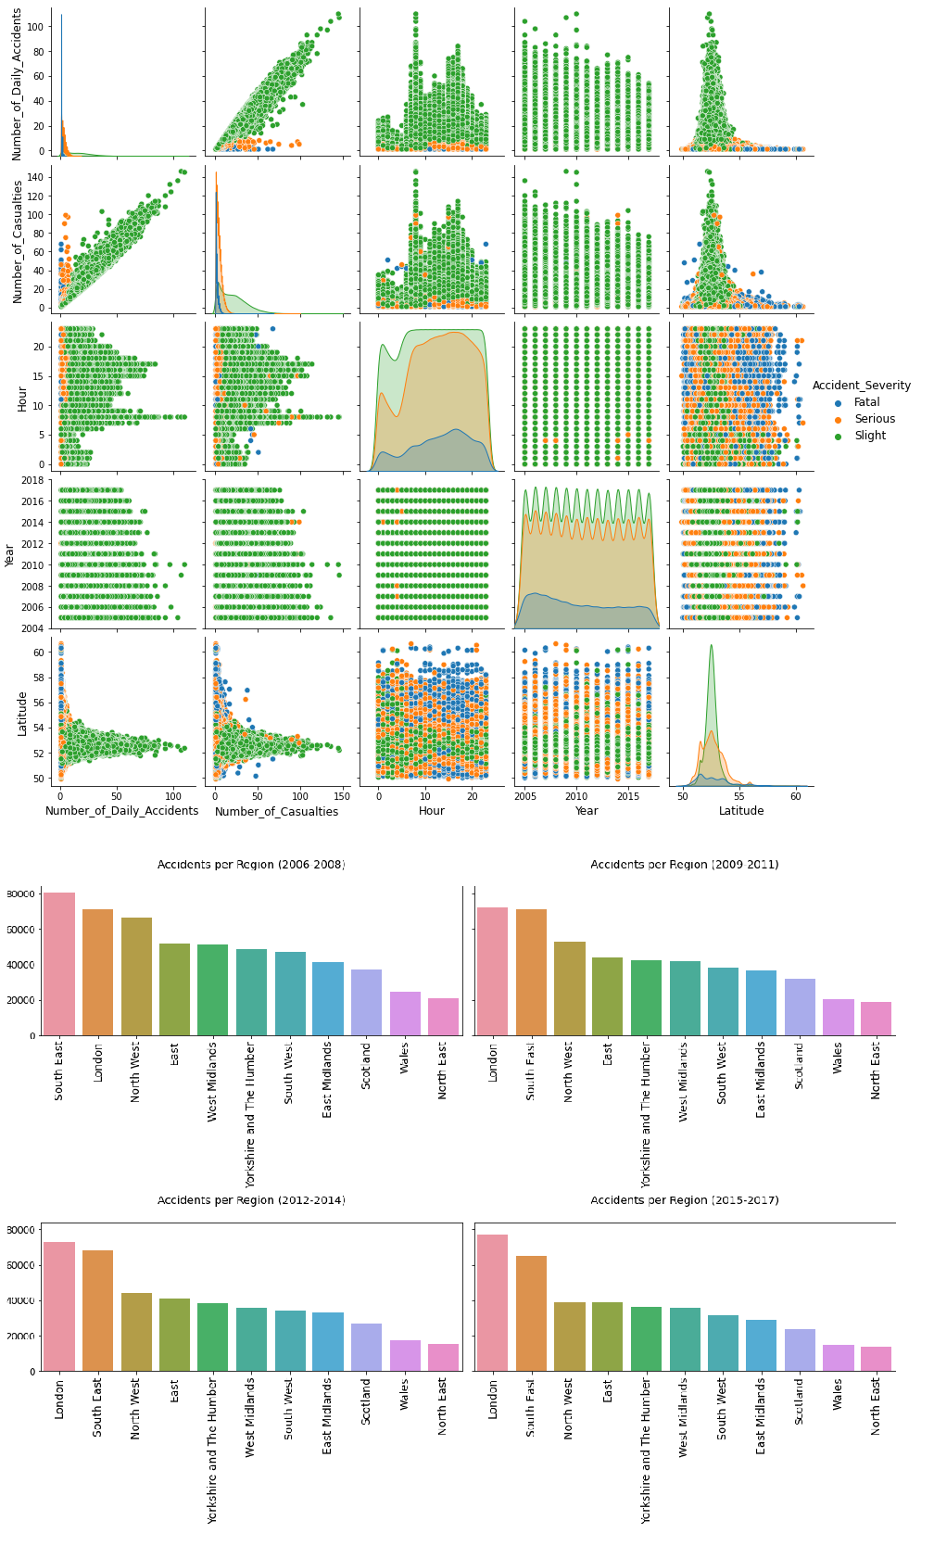

Fig.1. Pairwise distribution of variables aggregated by day (Top) and accidents distribution per year bins in top 15 regions in the UK (Bottom).

**Data quality**

Part of the columns was removed since they did not contribute to the analysis. The dataset contains missing values for time, latitude, longitude and speed limit columns but those are a small fraction of the dataset and from 2,047,256 observations 368 were removed. Overall, the dataset has a uniform time coverage as seen in fig.1, and despite of lacking data in Northern Ireland all latitude points are distributed from Isles of Scilly to Shetland Islands and longitude coordinates are scattered on a variety of Great Britain roads. Nevertheless, we found remote coordinates which could be classified as noises, but they should not influence the cluster analysis.

**Outliers**

The main criteria used for outlier detection considered the number of total accidents in each day (fig.2). We only identified 17 outliers and a close inspection revealed accidents occurred in 2005 and 2006 with London and Birmingham identified as hotspots.

Outliers from the number of casualties and vehicles per accident were inspected and three accidents with more than 80 casualties were found, with two of them having lower casualty figures based on news. Accidents involving at least 30 vehicles were investigated and confirmed, with the most prominent on 05/09/2013 in Kent involved dozens of cars and was caused by a dense fog at morning rush hour.

**December/YYYY**

**29/09/2006**

**18/11/2005**

**22/10/2005**

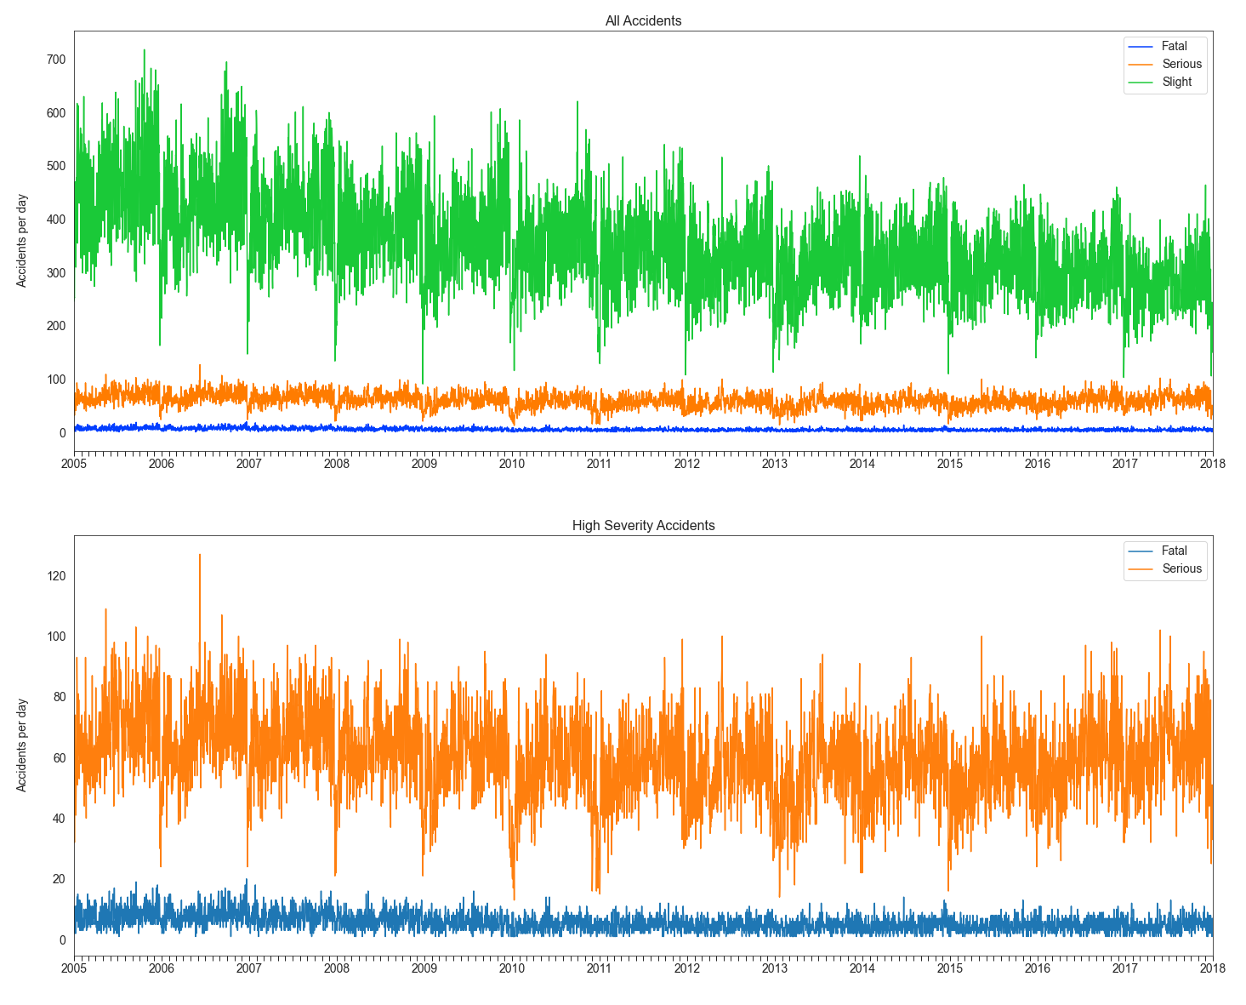

Fig.2. Analysis of accidents distribution and outliers split by severity type using temporal variation.

# Analysis

## Approach

In this work we will develop an exploratory analysis using Python and auxiliary libraries to create graphs and use human reasoning to support the analysis, visualisation and understanding of patterns. The analysis process will be separated into temporal and spatial components and continued via adequate computational methods through several iterations using filters and aggregation according to tasks. With computational aid we will apply data-mining algorithms, specifically DBSCAN and variations to investigate and visualise regions of interest and divide data into groups with similarities. Those regions will use high severity accidents within the UK and significant locations derived from algorithm results. For spatial analysis we shall consider data from shorter periods due to performance reasons and proximity between large quantity of points, which would hinder interpretation of maps and clusters, as we know the success of clustering methods is related to the similarity measure between data points[9].

1. **Temporal**

From sequences of instant events of accidents, we will build a top-bottom approach via yearly comparisons, seasonality from weeks, months, weekend/weekday and hours. Attributes like severity type, light condition, road speed limit, casualties will be considered during the following steps to identify patterns of temporal variation over attribute values.

1. Compare years, seasons and months distributions individually using line chart and bar chart.
2. Create bins from years and compare against attributes, then compare years, months, weekdays/weekends and hours using histograms and heatmaps.
3. **Spatial**

To perform spatial analysis, we will filter data according to temporal patterns and study the frequency of high severity accidents in the UK and subregions. Geographic locations and coordinates will be used to display data in density maps and artificial spaces to represent similarity between clusters with projections of high-dimensional space into a low-dimensional representation. To enhance visual displays, we will utilize a variety of visual variables of position, size, colour, etc.

1. Visualise and compare data from high and low severity accidents within regions in the UK.
2. Apply spatial variation on the same subset across hours of the day and road speed limit over number of casualties.
3. Visualise clusters in MDS projection and space-time cube after clustering.
4. **Clustering**

Based on spatial analysis we will apply DBSCAN following sklearn implementation and optimise parameters to calculate neighbourhood of points and assign them to clusters/noises. To select the best configuration, we should reflect on the number of clusters (automatically determined), items per cluster, visualise clusters distribution and analyse if results show similar density clusters.

1) Apply DBSCAN on high severity accidents for UK regions and compare results between clusters and spatial distribution.

2) Visualise a large cluster from step 1 with poor results from variable density regions and apply DBSCAN on points from this cluster.

3) Evaluate step 2 clusters and compare against local authority on lower density regions. If not possible apply DBSCAN again until reaching the city level.

4) Apply DBSCAN to step 3 clusters by light condition and compare.

5) Compare data from previous iteration using K-DBSCAN and visualise clusters in choropleth map.

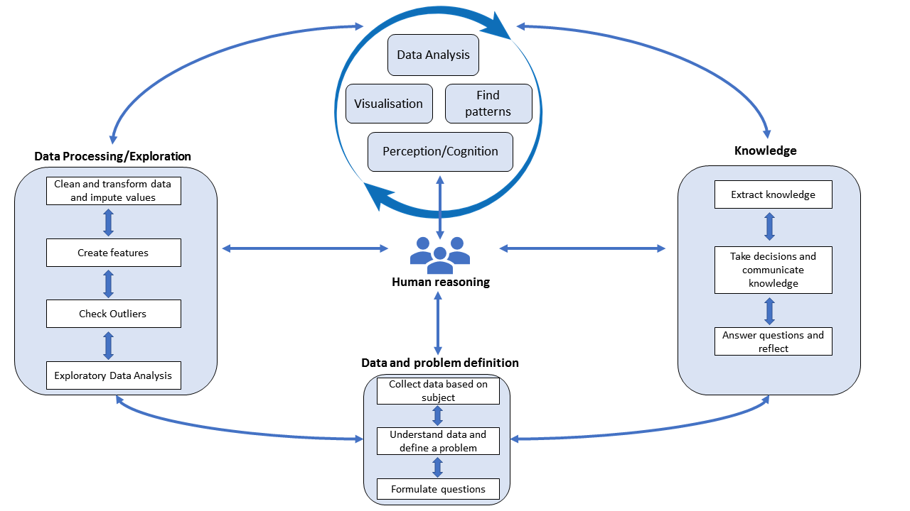Fig.3. A diagram containing the main steps of the analysis workflow.

## Process

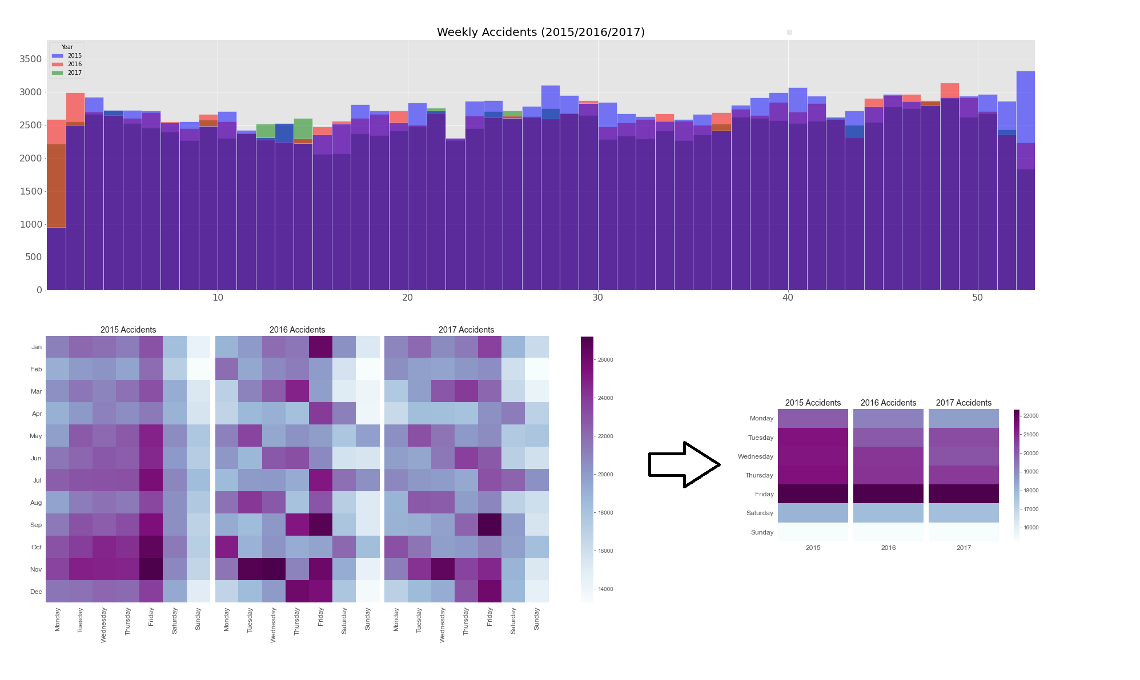

Fig.4. Composition of weekly accidents histograms (Top) and frequency heatmap of months and days of the week (Bottom) between 2015 and 2017.

1. **Temporal**

The initial analysis covers all data using temporal frequency of daily accidents in the UK with variation across years 2005-2017 (fig.2). The graph shows an average yearly decrease from over 700 accidents in 2005 to around 450 in 2015 with a stable trend over the last three years. Unsurprisingly, the days with less accidents are the ones near Christmas because from the 15 days with fewer accidents 11 are on Christmas or closer days when people normally stay at home with the family. There are trends over the years, with accidents decreasing during the first three months and increasing until June, then a short oscillation period happens, and another increase in the end of the year. This vary per region, but commonly peak periods happen in summer holidays with more people going for their destinations and throughout wintertime when there is less daylight or road conditions become worse. Nevertheless, this trend is not maintained for high severity types, as fatal accidents experimented a drop from 3000 yearly accidents to half of that and serious accidents fell until 2015 and increased until 2017.

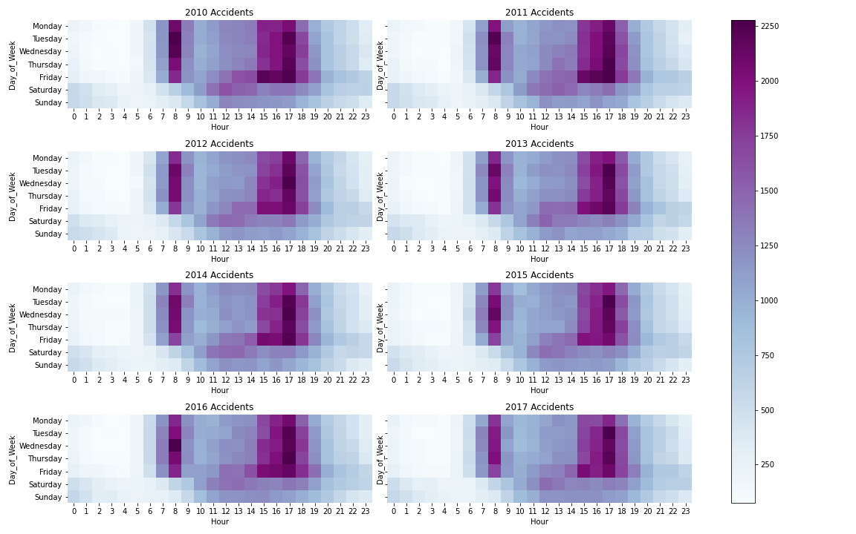

Fig.5. Frequency Heatmap of accidents per day of week and hour of the day from 2010-2017.

In fig.4 histogram we compared weeks of the year against each year to see periods with most accidents on 2015-2017 and use primary colours to simplify colour perception. In 2015 there are higher peaks in most weeks during the second semester and considerably fewer reports in January. As for 2016 there are less peaks compared to 2015, with the most prominent in November. Finally, 2017 has only 4 major peaks, and the entire distribution has analogous seasonality as years before and uniform behaviour with less variation between adjacent weeks.

Comparing fig.4 months against weekdays we observed November, July and January had most accidents, while February had lowest accidents due to outliers and not for being the shortest month. They mostly happened on Fridays, but differently by month with September-November-December peaks. Poor results on Friday could relate to driver behaviour as people are usually exhausted and have plans for the weekend, hence lack of attention or anxiety might be a contributing factor. Overall, Monday and weekends had the lowest figures, Friday and weekends had stable trends and diminished on remaining days across the years.

There are increasing patterns across Monday-Friday between 08:00-09:00 and 15:00-19:00 (fig.5), which means accidents are more likely to happen when people drive home than in the morning with other reasons including people taking passengers to their destinations. Noticeably Tuesday seems to be the most common day among the offender hours. However, this is an average and expected in medium/large density locations, but in rural areas this could be different. Between 11:00-14:00 we see a few accidents on Friday and Saturday, this might indicate time constraints of lunchtime period. On Saturday accidents reach a lower second peak at 17:00, indicating periods people spend more time outside. Comparing 2015-2017 we see a reduction on Monday-Thursday, but not on Friday and weekend. This could mean more people adopting public transport, bicycle, carsharing, respecting traffic laws, and working remotely.

1. **Spatial**
2. **Severity type**

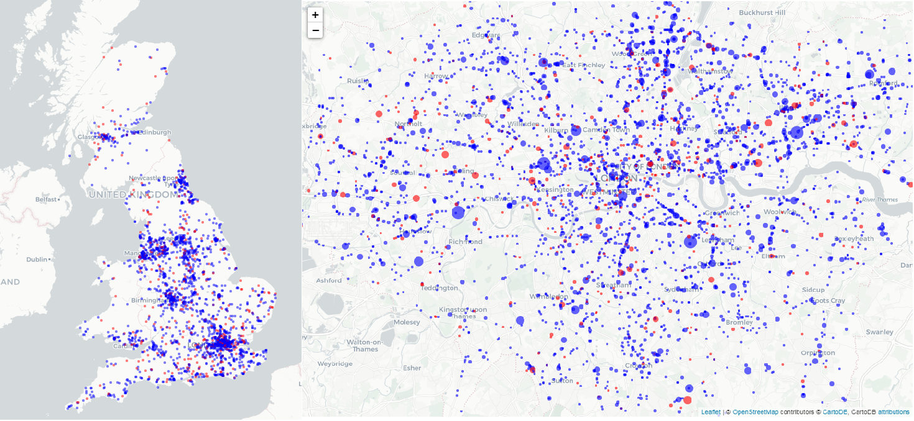

Fig.6. (Left) UK and (Right) London Density Maps - Markers in red are high severity and blue represent low severity accidents, both for accidents with multiple casualties.

Fig.6 analysis shows multiple casualty accidents between 2015-2017 with markers size based on casualties. The left part has 87,696 accidents and 5 large clusters of points related to main cities in the UK. The largest hotspot is the one in Greater London and surroundings, followed by Manchester, Birmingham, Leeds and Newcastle. Other cities like Glasgow and Cardiff have a perceptible size, but because they are not as close to smaller hotspots as others it is difficult to observe them as part of clusters. We see few points in low-density regions from smaller cities or remote areas and alongside the coastline, indicating accidents have higher frequency inside cities perimeter than between cities. The right part depicts 11,319 accidents in London for the same period and clustered points in Westminster and City of London, which are London divisions responsible for a relevant financial and insurance industry sectors and destination to many people. Westminster is home to several tourist attractions, and it is surrounded by several means of transport with high congestion levels. Unexpectedly, Barnet and Enfield were the boroughs with most accidents, even if their road density is lower, they have larger areas than Central London. Areas far from centre have small clusters which could be due to commuting, since those regions usually offer less public transportation options, however this could mean formation of small towns inside London.

1. **Hour/Speed limit**

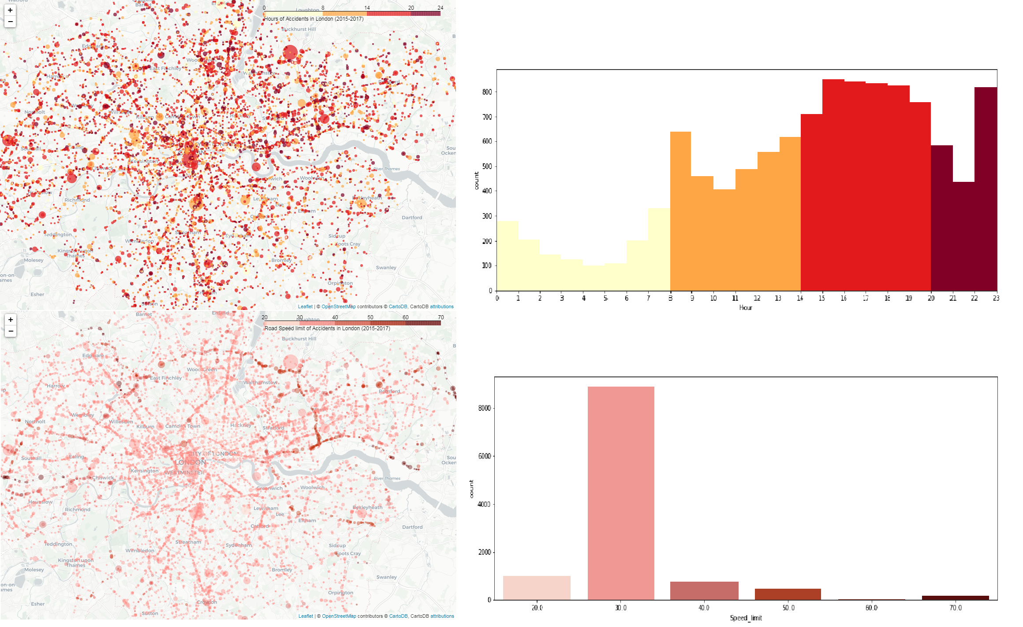

Edgware

Edmonton

Barking

Fig.7. London Density Map and Histograms of accidents in 2015-2017 with multiple casualties - Accident hours (Top) and road speed limits (Bottom).

We inspected the spatial distribution of accidents over hours of the day and road speed limits attributes (fig.7) and for the former we divided hours in unequal bins to highlight areas between 8:00-20:00 to see locations of accidents in peak hours. Most accidents happen in central locations or neighbouring regions from 14:00-20:00 with peaks between 15:00-19:00. However, clusters out of Central London are not easily detected, with a small number of accidents inside boroughs and others scattered in roads connecting to the centre. This can be seen in points connecting Edgware to centralized regions, and possible explanations include people commuting or using roads to reach other cities or parts of London. Usually, southern boroughs have fewer accidents, but the population density of those areas might explain this. Observations of accidents after 20:00 are sparse across the city, suggesting closeness to places near night destinations like pubs and restaurants. The bottom map shows the speed limit for most locations is within 20-30 mph, but accidents in roads with higher limits are frequent in outer zones and we distinguish accidents over the north circular road, which has up to 50mph restriction. In city borders we locate accidents within the highest limits, which is aligned to the 70mph national restriction of dual carriageways and motorways.

1. **Clustering**

**DBSCAN-UK**

To visualise high severity accidents locations and considering fig.6 results we know London is the single region with most accidents considering 32 local authorities and City of London. To address this task, we performed DBSCAN on geographic coordinates in radians from UK high severity accidents locations in 2017, because points were crowded in larger periods. This method utilizes two parameters being one called epsilon as a distance threshold for neighbourhood search and minpts as the minimum number of neighbours for each cluster[10]. We used haversine as distance function, largely recommended for geographic distance, and optimised parameters with k-NN distance plot and visual approaches. From a total of 24,204 accidents, results in fig.8 show 114 clusters with 1,513 noises and a large cluster of 14,424 members was created over Greater London, Birmingham, Leeds and other locations. This is unexpected because in density maps London is recognized as a unique high-density cluster, however the algorithm does not successfully detect clusters with variable density. Clusters formed over Cardiff and Newcastle seem to have a more homogenous density. One example of low efficiency of epsilon choice is the association of Glasgow and Edinburgh to the same cluster, because lower-density regions (e.g., Falkirk) between the two larger cities were identified. We ran DBSCAN again (rightmost) on largest cluster members with improved results and a differentiation of London cluster from smaller cities as Birmingham and Leeds.

**Kingston upon Thames**

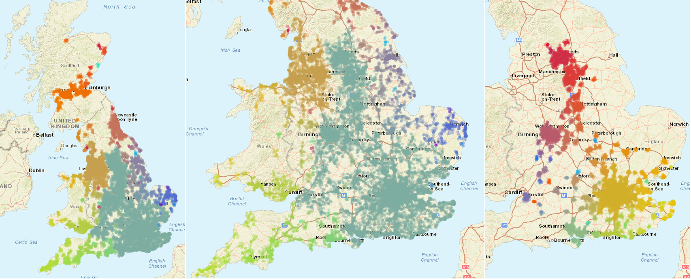

Fig.8. DBSCAN Clustering of high severity accidents in 2017.

**DBSCAN-London**

Motivated by previous results and based on accidents per region (fig.1) we ran DBSCAN on 8,769 observations in London (fig.9). Data was filtered between 2015-2017 and longitudes and latitudes of -0.50/0.30°E and 51.29/51.68 8°N. The optimised algorithm displayed 34 clusters and 464 noises, with a cluster of 7,045 members and higher density in central regions than in borders. The characteristics of the phenomena and distribution show a low clustering efficiency, and one interpretation from the large cluster formation might be the similarity between accidents in most roads connecting suburbs to the centre, that are not identified as other clusters or noises. Moreover, in the same cluster we see hotspots in Westminster, Tower Hamlets and surrounding boroughs, with smaller clusters found close to Kingston-upon-Thames, Romford and other arbitrary shaped clusters.

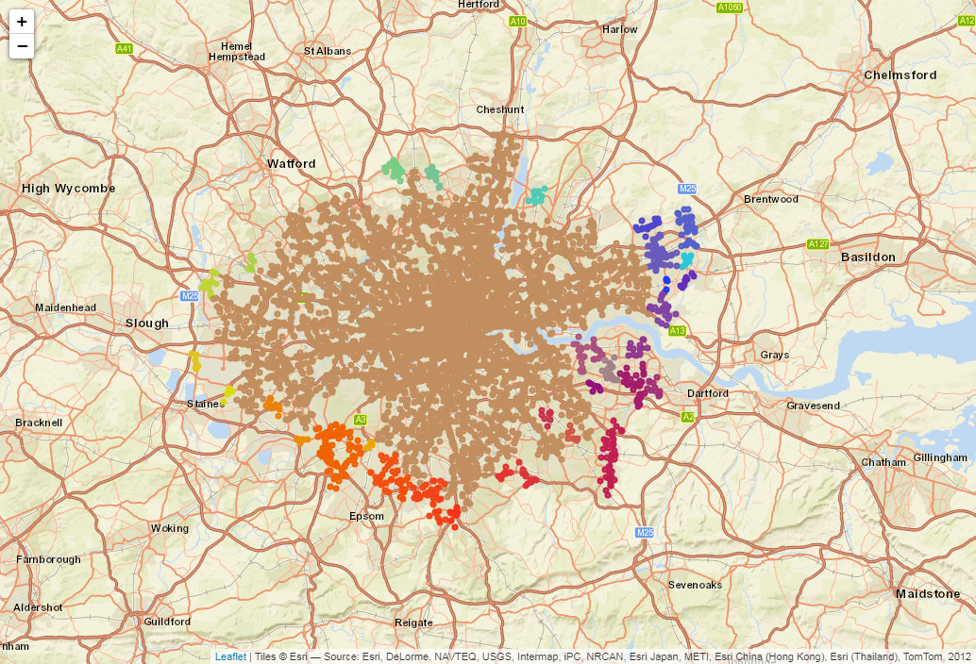

**Kingston upon Thames**

**Orpington**

**Bexleyheath**

**Romford**

Fig.9. DBSCAN Clustering of London high severity accidents in 2015-2017.

**DBSCAN-Light condition**

To understand how accidents are affected by light conditions we grouped data (fig.10) and found different clusters structure and number of clusters, with darkness unidentified regions appearing in daylight suggesting a higher density of accidents near Bromley and Hillingdon. Thus, even considering darkness as contributing factor, we know people usually have diurnal habits and are more active during daylight, except for winter.

**Bromley**

**Hillingdon**

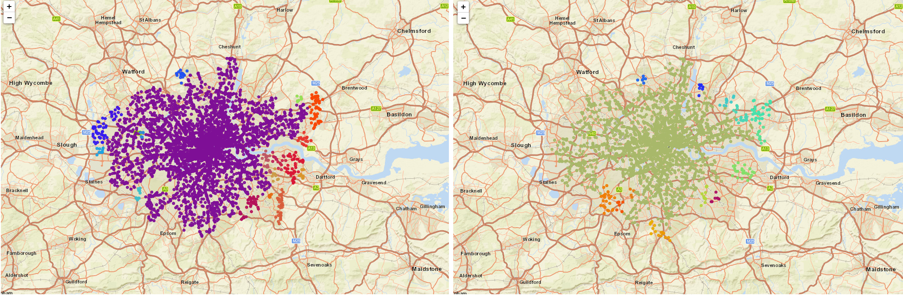Fig.10. DBSCAN Clustering of London high severity accidents in 2015-2017 aggregated by light conditions. Left: Daylight. Right: Darkness

**K-DBSCAN-London**

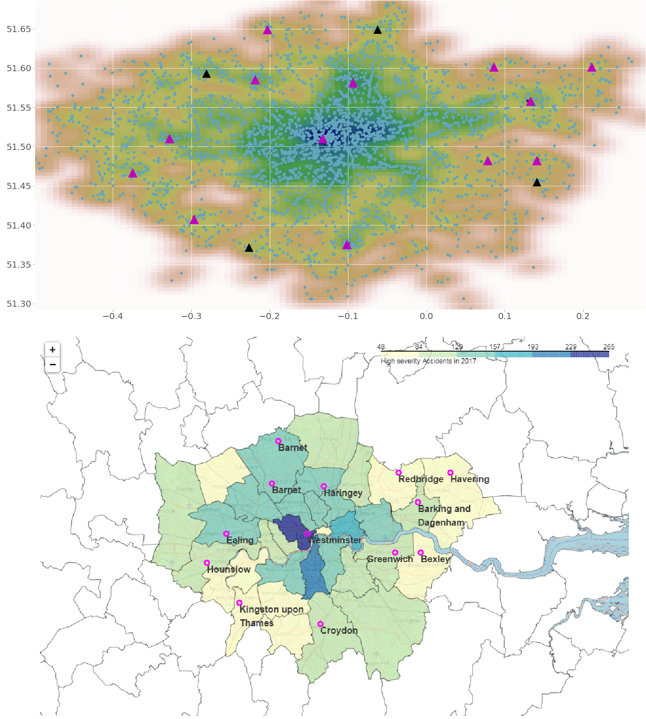

Fig.11. K-DBSCAN of accidents in 2017 (Top) and representation of centroids in choropleth map (Bottom). Valid cluster centroids in magenta and noise cluster centroids in black.

In this work[6], authors proposed a DBSCAN variation (K-DBSCAN) to address variable density regions, that instead of relying on a global parameter to calculate clusters the algorithm looks at the local maxima from the KDE distribution to find the number of valid clusters and centroids before the clustering itself. Inspired by this work we implemented K-DBSCAN and results (fig.11) exhibited 12 smaller clusters in boundaries instead of assigning points to the largest cluster or noises. Those regions account for less accidents compared to Central London, as we see on choropleth map. However, we note that due to the distribution of major roads from boroughs to the centre we fail to identify clusters in less dense locations containing similar effect size, with the distance between accidents as an important factor.

## Results

1. Analysis shows declining trends of accidents, but serious/fatal had opposite effect since 2015. Monthly patterns across years have accidents dropping from January to March, then increasing until July, a second drop in August, and growing from September-November with slightly decrease in December. Friday is the most impacted day followed by Tuesday-Wednesday-Thursday sharing similarities, then Monday, Saturday and Sunday having lowest frequency respectively. Hours of day peak occurs at 08:00-09:00 and another at 17:00-18:00, closely followed by 15:00-17:00 and 18:00-19:00.
2. Accidents are mostly frequent in large urban areas with Greater London responsible for 20% of UK, then Birmingham, Leeds and remaining cities, and London, South East, North West and East regions have the highest figures respectively. This pattern is also present considering only high severity accidents. Ideally, we would like to see numbers for regions proportionally to populations, but results might be biased.
3. As opposed to belief, accidents happen more frequently on 30mph roads then 70mph, due to stress levels or distraction from false sense of security. Number of casualties, vehicles, and road type were useful too, because we can find higher frequency of accidents in major roads from large population cities with more vehicles and casualties then in remote places.

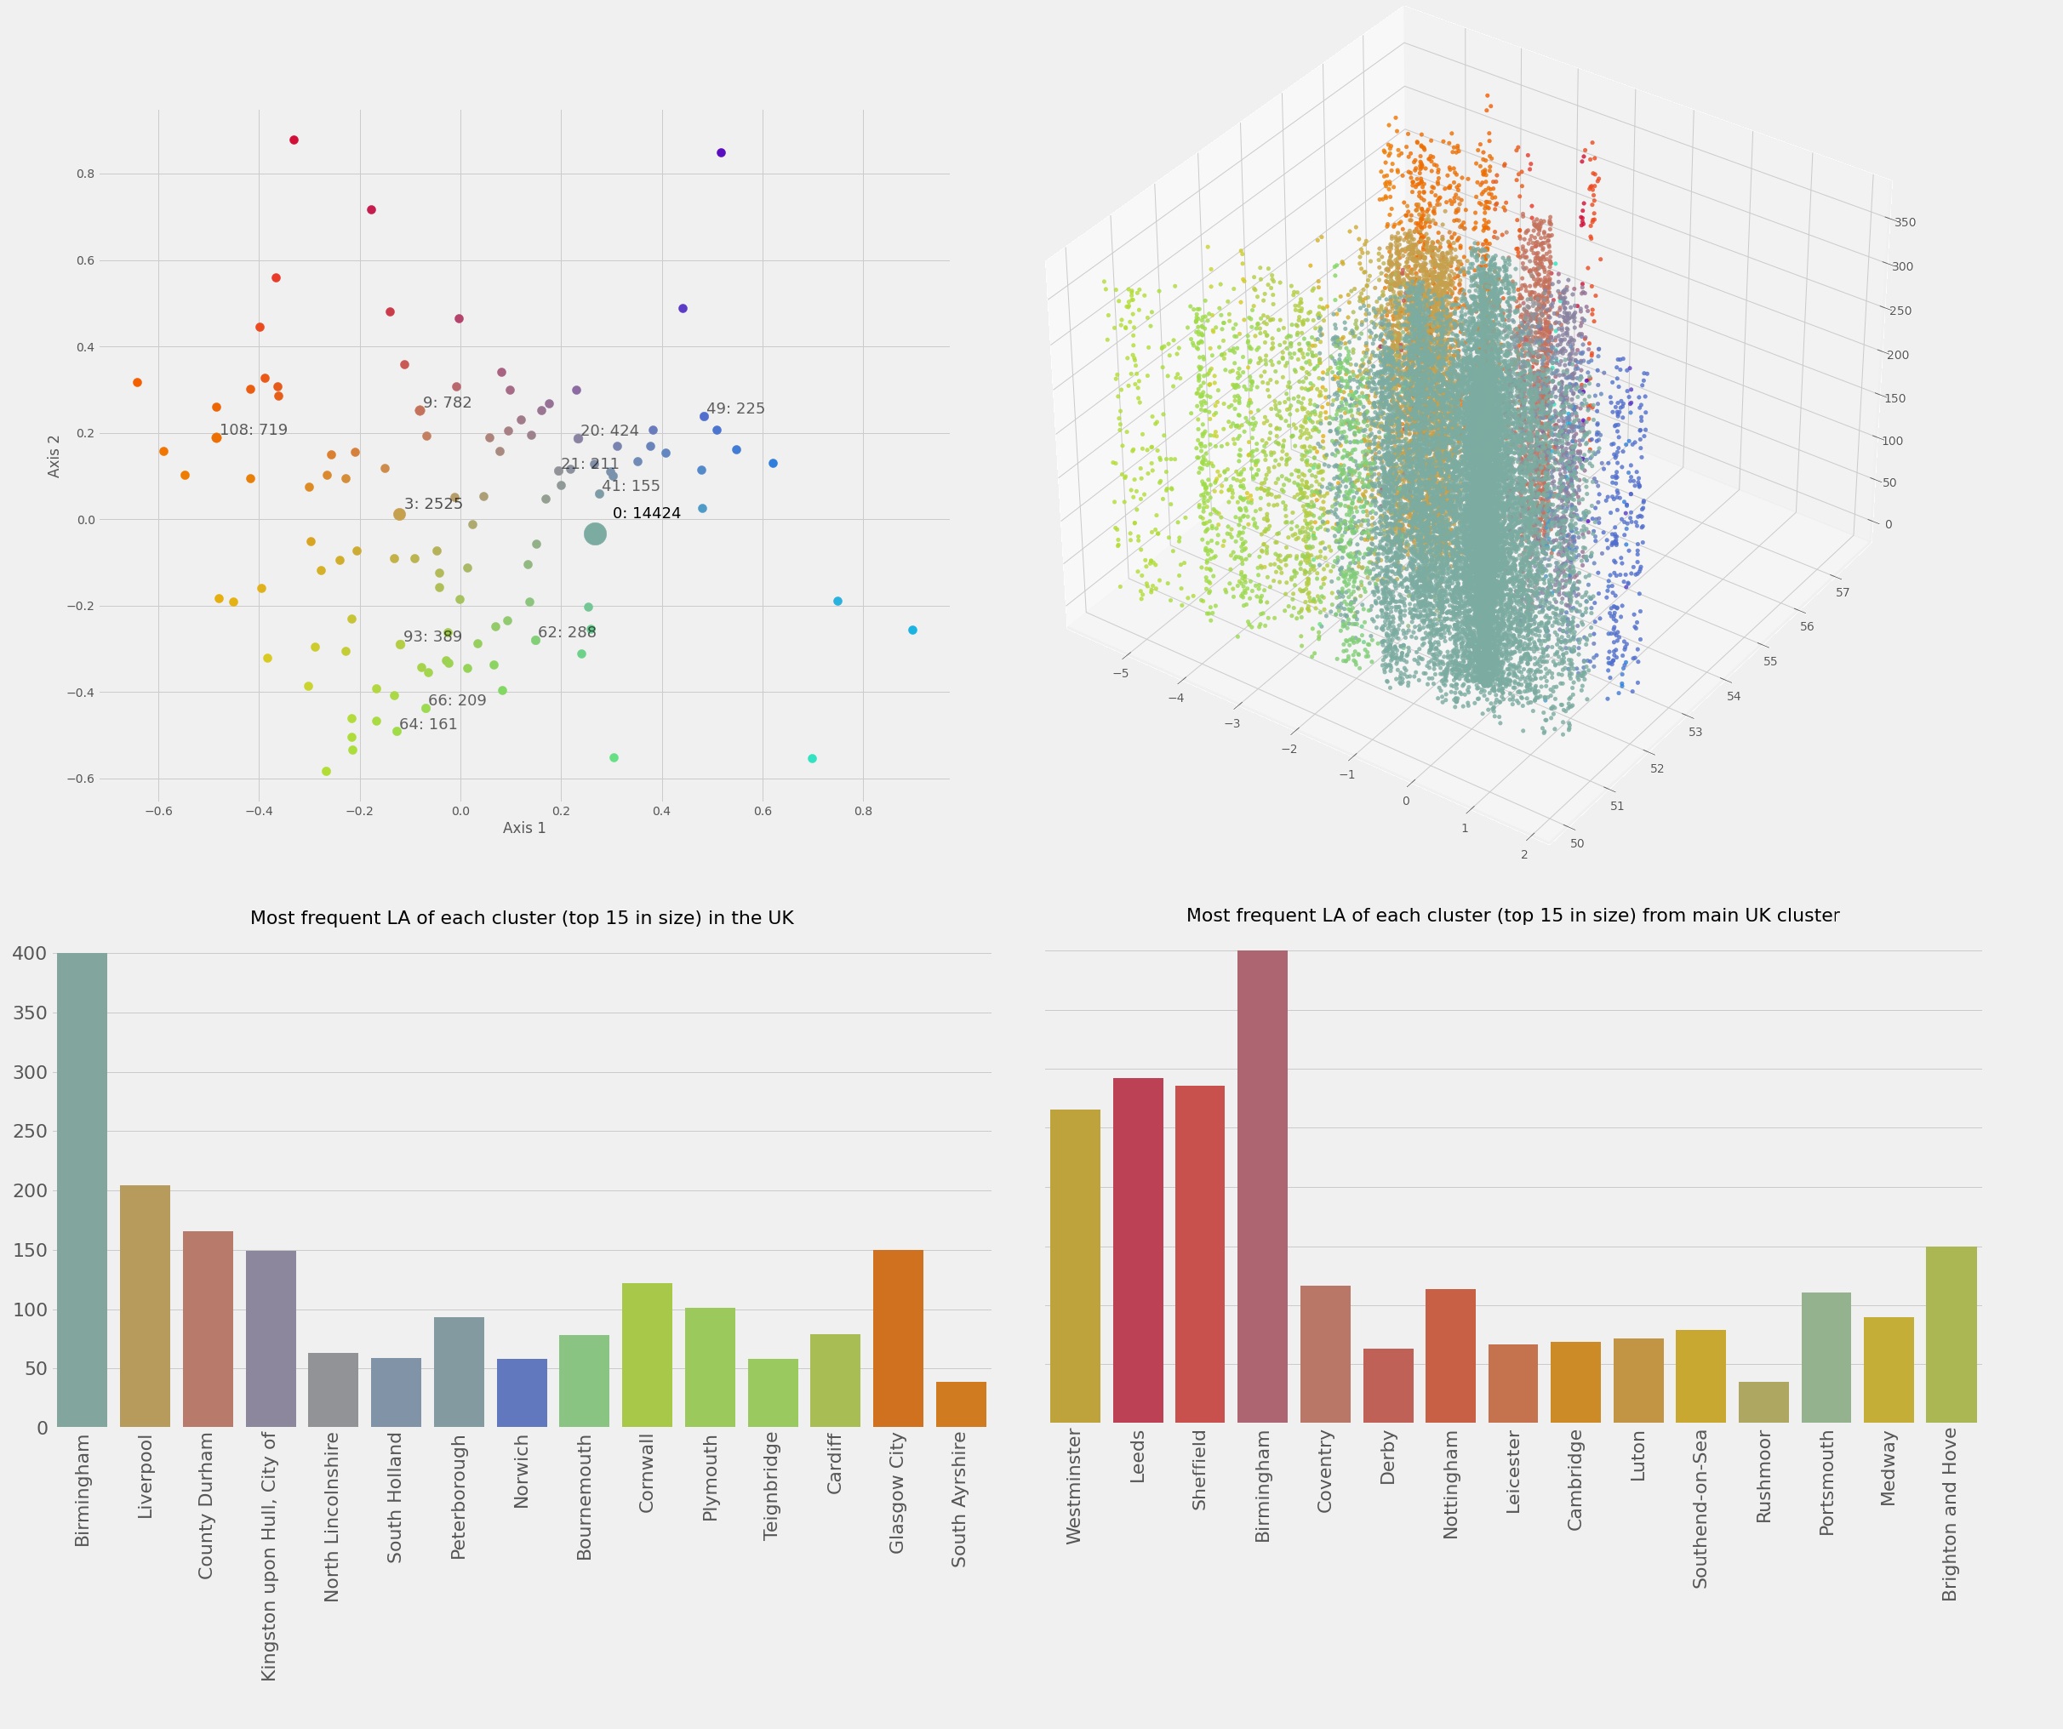

Fig.11. MDS projection, representation of space-time cube and distribution of local authorities from DBSCAN clusters. Top left: space and time variables projection. Top right: projection using geographic coordinates in x and y-axis and days of the year along the z-axis. Bottom left: local authorities with maximum number of cluster items among top 15 UK clusters. Bottom right: same distribution as bottom left based on the main cluster within the UK.

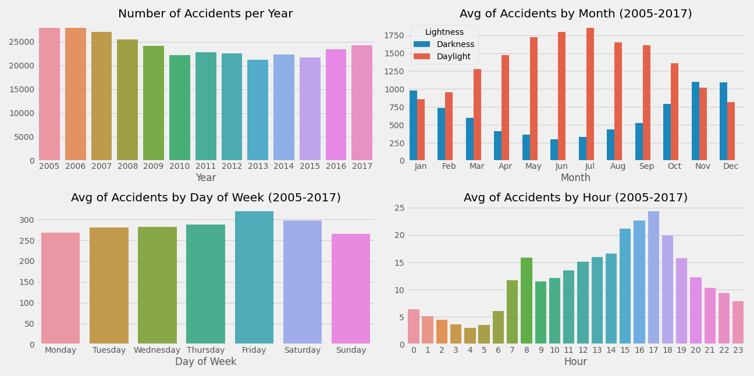

Fig.12. Summary statistics of temporal variables from high severity accidents for all locations within the UK between 2005 and 2017.

# Critical reflection

The process of data collection and understanding was crucial to propose research questions to a well-defined problem, since we explored statistics and data properties before.

We observed in fig.2 decreasing trends of accidents frequency and temporal patterns comparing months against weekdays/weekends and hours, however the trend in 2013-2017 is different for high severity accidents (fig.12). Overall patterns were explored in fig.4/fig.5 with September-November being the most affected and December-February the least, indicating less people using cars at that time combined with other factors as a more careful driving during winter. This was unexpected since more challenging road conditions are commonly present in winter. Fatal accidents are most likely to occur in summer and daylight conditions, except from November-January, because there are less daylight hours per day. In addition, the most frequent day is Friday and hours around 15-00:19:00, with lowest numbers over the weekend. However, if we only consider peak hours then Tuesday would be the day with highest frequency.

Hotspots were found in most central roads (e.g., City Road) and accidents commonly happen in 30mph roads, but there were different patterns between speed limits and fatal accidents in London, with most accidents occurring in 70mph roads, meaning that accidents are more dangerous in high speed roads. The 30mph limit in central regions is coherent as people share smaller areas during short periods and reduced limits ensure minimum traffic flow. We analysed London offender days to explore accidents spatial proximity and temporal dependence, though not frequent we identified accidents with similar location within an hour period, but specialized techniques are required to improve.

DBSCAN clustering for high severity accidents was helpful to find high-density locations separated from lower density regions, and the best results were found in second clustering (fig.7) for larger and less variable density regions in England. Clusters provided insights about local authorities with distinction made between London and other cities (fig.7/fig.11 histogram). Swindon and Cambridge, previously hidden, were recognized as unique hotspots. Clustering in London detected one high-density cluster and failed to find clusters from suburbs in variable density regions, being conurbation in London a contributing factor. Therefore, we implemented K-DBSCAN in London and detected different and varied clusters distributed among 13 groups.

We combined multiple attribute values to visualise clusters in single display, but more adequate time periods would be necessary to avoid confusion. In addition, considering roads as features into distance functions would be motivating, but that would require detailed analysis of London road and postcode distributions.

It would be beneficial to apply another clustering methods in London such as V-DBSCAN[6], which adopts local density parameters and considers density changes as regions become more distant from centroids. Another approach might be clustering using smaller spatial distributions far from Central London with smaller temporal intervals and interaction. This might enable patterns because some points in variable density regions could disappear and others generate smaller clusters. Finally, vehicles metadata would provide valuable insights, nevertheless we should ponder on ethical considerations about the use of GPS-based movement tracking.

Table of word counts

|  |  |
| --- | --- |
| Problem statement | 252 |
| State of the art | 449 |
| Properties of the data | 500 |
| Analysis: Approach | 500 |
| Analysis: Process | 1500 |
| Analysis: Results | 202 |
| Critical reflection | 500 |

References

[1] L. Jackson, “Road Accident Statistics,” p. 12.

[2] “Road traffic statistics (TRA),” *GOV.UK*. https://www.gov.uk/government/statistical-data-sets/road-traffic-statistics-tra (accessed Dec. 28, 2020).

[3] A. Tyagi, A. Kumar, A. Gandhi, and K. Mueller, “Road Accidents in the UK (Analysis and Visualization),” *ArXiv190802122 Cs*, Jul. 2019, Accessed: Dec. 27, 2020. [Online]. Available: http://arxiv.org/abs/1908.02122.

[4] P. S. Costa, N. C. Santos, P. Cunha, J. Cotter, and N. Sousa, “The Use of Multiple Correspondence Analysis to Explore Associations between Categories of Qualitative Variables in Healthy Ageing,” *J. Aging Res.*, vol. 2013, pp. 1–12, 2013, doi: 10.1155/2013/302163.

[5] H. Z. Selvi and B. Caglar, “Using cluster analysis methods for multivariate mapping of traffic accidents,” *Open Geosci.*, vol. 10, no. 1, pp. 772–781, Dec. 2018, doi: 10.1515/geo-2018-0060.

[6] E. Pla-Sacristán, I. González-Díaz, T. Martínez-Cortés, and F. Díaz-de-María, “Finding landmarks within settled areas using hierarchical density-based clustering and meta-data from publicly available images,” *Expert Syst. Appl.*, vol. 123, pp. 315–327, Jun. 2019, doi: 10.1016/j.eswa.2019.01.046.

[7] D. for Transport, “Road Safety Data,” Sep. 30, 2020. https://data.gov.uk/dataset/cb7ae6f0-4be6-4935-9277-47e5ce24a11f/road-safety-data (accessed Jan. 06, 2021).

[8] N. Andrienko, G. Andrienko, S. Miksch, H. Schumann, and S. Wrobel, “A theoretical model for pattern discovery in visual analytics,” *Vis. Inform.*, p. S2468502X20300930, Dec. 2020, doi: 10.1016/j.visinf.2020.12.002.

[9] J. Irani, N. Pise, and M. Phatak, “Clustering Techniques and the Similarity Measures used in Clustering: A Survey,” *Int. J. Comput. Appl.*, vol. 134, no. 7, pp. 9–14, Jan. 2016, doi: 10.5120/ijca2016907841.

[10] S. Akbar and M. N. A. Khan, “Critical Analysis of Density-based Spatial Clustering of Applications with Noise (DBSCAN) Techniques,” *Int. J. Database Theory Appl.*, vol. 7, no. 5, pp. 17–28, Oct. 2014, doi: 10.14257/ijdta.2014.7.5.02.